**Example: Call a Function After Clicking a Button**

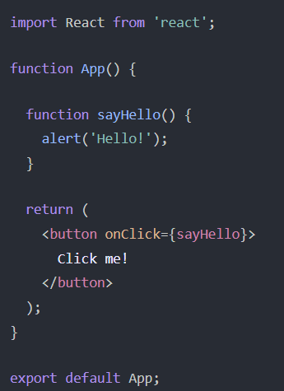

**Example: Call an Inline Function in an onClick Event Handler**

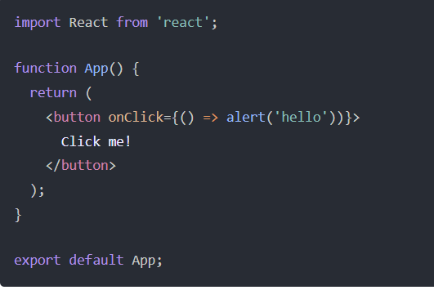

**Example: Updating the State in an onClick Event Handler**

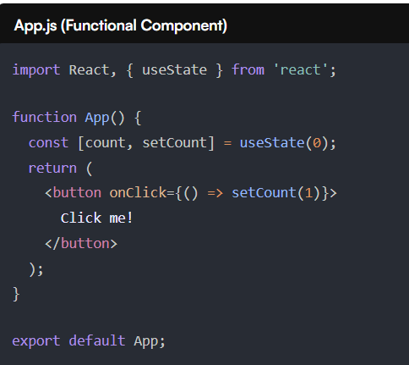

**Example: Pass an Input Value from the onChange Event in a React Component**

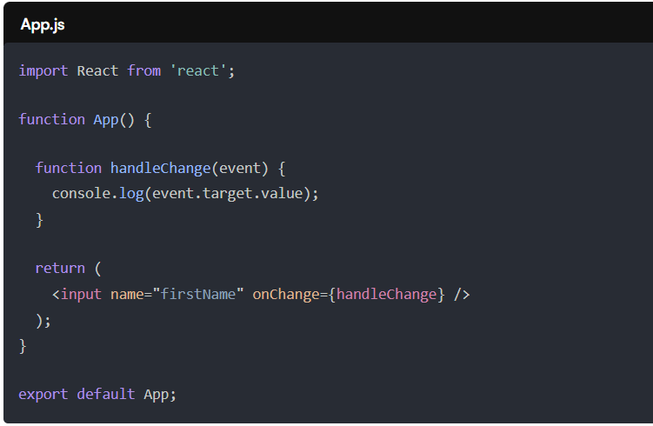

An onChange event handler returns a ***Synthetic Event*** object which contains useful meta data such as the target input’s id, name, and current value.

We can access the target input’s value inside of the handleChange by accessing ***e.target.value***. Therefore, to log the name of the input field, we can log ***e.target.name***.